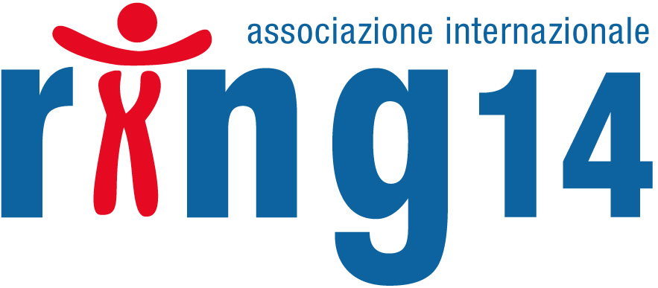

NEWSLETTER AUGUST-OCTOBER 2008

NEWS

2nd INTERNATIONAL CONGRESS ON RARE NEUROGENETIC DISEASES
Already available in our web site following documents:
- Communiqué
- pictures
- press review
- thanks (letter to DAR VOCE INFORMA) (MANY THANKS of Stefania Azzali)
- It’s going to be inserted also the videoregistration of the scientific day

Many thanks by heart to all the families and the volunteers who supported us making possible that wonderful event!

PROJECT “BROTHERS ON BOAT”
The brothers of persons suffering disability are, for evident reasons, enjoying less attention, less named in the literature and less taken into consideration as regards the organization of events. In fact, when we speak of “family” we refer particularly to the parents and activities are concentrated on them ….. (follow up)
We are trying to involve, within November, other associations of our territory in order to elaborate also moments of socialization before and after navigation. In a second time, from December, the project will be opened to associations on the national territory.

The associations of Reggio Emilia interested in the project are kindly requested to get in touch with us urgently!

HAND BALL AND SOLIDARITY:
During the sport season 2008/09 Gammadue Secchia Rubiera will promote and advertise, collaborating with us, the action of the association through many initiatives ......(follow up)

CHARITY EVENTS:
An evening pinnacolo and one theater performance for supporting the Research on rare neurogenetic diseases. Two charity events respectively on thursday October 16th and friday october 24th…..
(see communiqué – see initiatives)

CHARITY STANDS AT THE HOSPITAL:
Also for this year the association will be present with their charity stand at the Santa Maria Nuova Hospital of Reggio Emilia on two days : tuesday, November 11th and monday, December 15^{th.}
On saturday, Decemebr 13th and sunday, December 14th thank to the collaboration of Maiolo family there will be two charity stands for our association in Varese province.

PRESS REVIEW :
last up-dating on-line ......(follow up)

OUR CHILDREN AND THEIR BIRTHDAYS:

Kibble Laura – 2nd August 1998 (Great Britain) - caz.kibble@virgin.net

Hiwaizi Jiana – 10th August 2006 - s.hiwaizi@savanastudio.com, surudhiwaizi@hotmail.com

Macdonald Timothy Michael – 16th August 1996 (Canada) - lorraine@syd.eastlink.ca

Hadley Luke Michael – 20th August 2006 (U.S.A.) - karahadley@yahoo.com

Wood Shelby – 22nd August 2003 - shelbyjatewood@hotmail.com

Francois Nolene – 23rd August 2001 - bea.francois.audic@wanadoo.fr

Taronno Ilaria – 24th August 1988 (Italy) - info@villailaria.com

Granard Elijah – 29th August 2000 (U.S.A.) - tgranard@gmail.com - www.ring14.net

Manning Elisabeth – 29th August 1986 (U.S.A) - manning02@comcast.net

Wright Vaughn – 4th September 1992 (Great Britain) - d_arcy@hotmail.com

Evans Rachel – 5th September 2002 (Great Britain) - jevans3858@aol.com, gracielaevans68@aol.com

Nunn Lisa – 6th September 1983 (U.S.A.) - agt49@alltel.net

Dubois Joshua – 11th September 2005 (France) – louhubdub@neufr.fr

Sumpton Mandie – 17th September 1997 (Great Britain) - mandiesumptonnotts@hotmail.com

Brahimi Samy – 4th Octobre 2003 (France) - guemlla@caramail.com

Palmer Bill e Ruth – 15th October 1984 (U.S.A.) - rbpalmer@pacbell.net

Rozenberg – 22nd October 2003 (Olanda) - jac.roz@tiscali.nl

Tongi Finelea – 22nd October 1999 (U.S.A.) - lauratongi@hotmail.com, lauratongo@hotmail.com

Llewellin Jodie – 26th October 1991 (Great Britain) - traceybell38@aol.com

Fiorentino Sabrina – 26th October 1995 (Italy) - lucianoeffe@tiscali.it

Marin Sara – 30th October 1996 (Spain) - inuk2000@terra.es

Should you find some mistake to point out in the list of birthdays, please send an mail to: info@ring14.it

“A special and tender thought in memory of ALL OUR LITTLE ANGELS who are looking at us from the sky following us on the way”

THE NEW FAMILIES

Fisher Tracy with Jakes – Ring14 - tracyfisher253@msn.com

Likens Robin with Baylor – Ring14 - robin.likens@med.va.gov

Hudspeth Karen - Ring14 (U.S.A.) - blessedbyhim1@embarqmail.com

Spano Stefano and Dalu Monica with Simone – (Italy) - dalumonica@yahoo.it

Dervishi Elena and Arben with Marianna and Martina - Deletion 14 (Italy) - arbenelena.dervishi@libero.it

Ulberti Laura with Simone - Deletion 14 (Italy) - laura.ulberti@telecomitalia.it

Tontini Luca and Giovanna with Marco – Deletion 14 (Italy) - luca.tontini@tele2.it

Franco Lucia with Giada - Ring14 (Italy) - yanluca@hotmail.it

A hearty welcome to all new families and many thanks to all of you for the collaboration!!

WEB SITE

We remember you that our web site www.ring14.org has been renewed.
Even maintaining the content unchanged we have reorganized the voices in order to make it more accessible and practical to reach.
Unfortunately, in spite of our good will, a lot is still to be translated into the main languages.....(follow up)
Among the novelties it is worth recording:
- Insertion of search field through key word
- Activation of the forum of discussion open to the registered members
For the time being subjects will be proposed by the association, even on external suggestion and with the supervision of a mediator. We invite you to participate the proposed discussions (if you are already registered insert a contribution - for registering click here).
The request of registration to the site is compulsory to enter the reserved area (forum and children histories). Each user will get a personal access password and code. Who is already registered must reniew the registration through request to the site.

THANKS

Many heartily thanks to Enterprises and Associations for the generous grants:

- Cacciavillani s.r.l.
- Righi s.r.l.
- Cerve s.p.a.
- Marella
- Poledil
- Conad Albinea
- SIT
- Planetario
- Matelli
- Lions Club Reggio Emilia Host
- Lions Club Canossa Val d’Enza
- Associazione Alpini RE
- Gruppo teatrale I Guitti
- Officina OMG

Private persons:

- Maiolo family
- Sanguanini family
- Ingangi family
- Azzali Mirto
- Torelli Paola
- Bruni Daniela
- Dugnani Marco
- Messori Paolo
- Prampolini Marisa
- Dignani Elena and Stefano
- Gozzi Giovanni
- Renata and Michele
- Umberto and Vilma
- Vecchi Davide

HOW TO SUPPORT RING 14

MONEY-BOXES:
The association bought terra-cotta money-boxes to be distributed to stores for fund raising. Even if you are not members of the Association but you wish to help us in that project, if you have some trusty stores available to collaborate, don’t hesitate to contact us!

VOLUNTEERS:
We are looking for volunteers among students, mother-language persons, teachers and all who know foreign languages to help us in translating the texts reported in our web site. Requested languages are: English, French, Spanish, German. The texts to be translated will be assigned according to the competence level. Please help us!!

MEMBER’S QUOTA:
We remember to our partners and families who have not yet provided that the transfer for the annual member’s quota is of Euro 50 per person / family to be made to the following bank coordinates:

GRANTS:
- free grant by bank transfer to DEUTCSCHE BANK IBAM: IT 46 C 03104 12800 000000820369 in the name of: "ASSOCIAZIONE INTERNAZIONALE RING14", or through credit card directly from our site. Grants can be deduced from annual statement of incomes.

- Destining thel 5 X 1000 on the annual statement of incomes signing in the specific area: “support of voluntary service, of no-profit association with social utility….” And indicating in the same area the fiscal code of our Association Ring14 : 91105800352.

- purchasing our solidarity bombonnières on the occasion of marriages, baptisms and Holy Communions

- Making offers in memory of …..

- purchasing our articles at the charity stands or directly from our site.

In order to cancel you from this newsletter send a mail to info@ring14.it with subject: effsce mei

